1.Briefly Describe the artifact. What is it? When was it created?
The Artifact I’ve chosen is the Travlr Getaways project. It is a full-stack / MEAN-stack booking platform originally developed during the course: CS-465 Full Stack Development last semester. during the course I followed a guide on MEAN-stack (MongoDB, Express.js, Angular, Node.js), the application features both a customer-facing website for browsing travel destinations with an administrative interface through angular for managing data within the database. The artifact represents a full-stack solution with server-side rendering via Handlebars templates, RESTful API endpoints, and database integrations.

Picture of Trip Layout Before Enhancement:
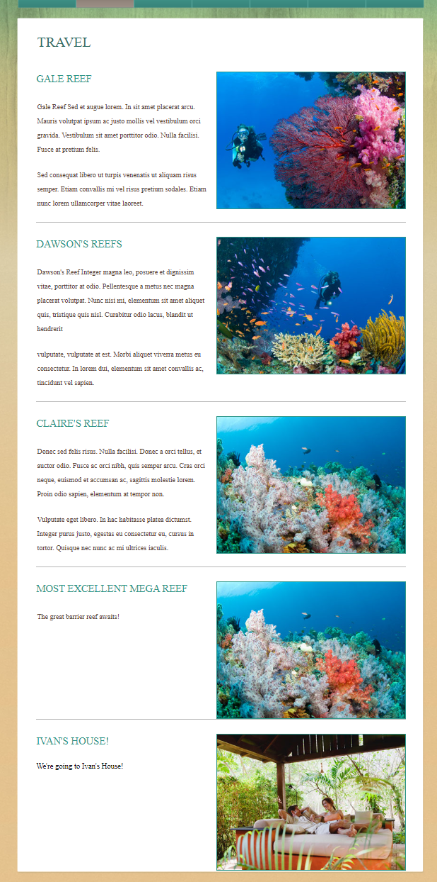

2.Justification for the Inclusion:
I selected this artifact for my ePortfolio because full-stack is considered the bread and butter of software engineering design. It branches out into other categories such as frontend, backend, databases, and GitHub collaboration or CI/CDs. Website, program, and database curation is needed in many different online facets. (Like Oil & Gas, Medical, Logistics, shipping, IT firms branching to mom&pops)
The Problem:
The original templates were designed for a static HTML with exactly three travel destinations. When the application was converted to use Handlebars templating and MongoDB for dynamic content and data addition / editing, a layout flaw in the website’s UI appeared, adding more than three trips to the database (because 3 was the original default amount) caused a visual problem, Images began overlapping with the separator lines and the white space between them was inconsistent, and the appearance lost professionality.
The Solution:
Through debugging, file searching, and general understanding of the full-stack environment. I identified a few CSS issues that caused this problem.
- Issue 1: Float Containment Failure: The images used float: right; to position themselves, but the parent <li> containers couldn’t properly contain these floated children. This caused container height collapse and overlapping content as more items were added.
- Solution: I added overflow: hidden; to #sites li, which created a block formatting context, that forces the parent container to acknowledge and contain its floated children
- Issue 2: Inconsistent Padding Accumulation. The template applied 24px bottom padding to every <p> tag via #contents p. The original three static entries each had two paragraph tags, creating consistent spacing. However, new database entries with different description lengths accumulated different amounts of padding, resulting in uneven visual rhythm.
- Solution: Removed the paragraph-level bottom padding and instead applied uniform 30px padding-bottom to the #sites li containers themselves, ensuring consistent spacing regardless of content length or number of paragraphs.
Skills that this enhancement demonstrated:
- Problem analysis: Identifying the root cause of the website’s formatting failure, pinning it down to the structure of the file structure, and pinning it to the CSS layout failure in content that was not made to be future proof.
- Frontend Engineering: Understanding CSS box model, float behavior, and block formatting contexts.
- Scalability Thinking: Recognizing that a design working with static data may fail when connected to a dynamic database.
- Code Investigation: Tracing through cascading stylesheet to understand how multiple selectors interact.
Code Changes:
/* Before */

#sites li {
padding-bottom: 0;
}

#contents p {
color: #5a4535;
font-size: 15px;
line-height: 30px;
margin: 0;
padding: 0 0 24px 2px;
}

/* After */

#sites li {
padding-bottom: 30px;
overflow: hidden;
}

#contents p {
color: #5a4535;
font-size: 15px;
line-height: 30px;
margin: 0;
padding: 0 0 0px 2px;
}

Picture of Trip Layout After the Enhancement:
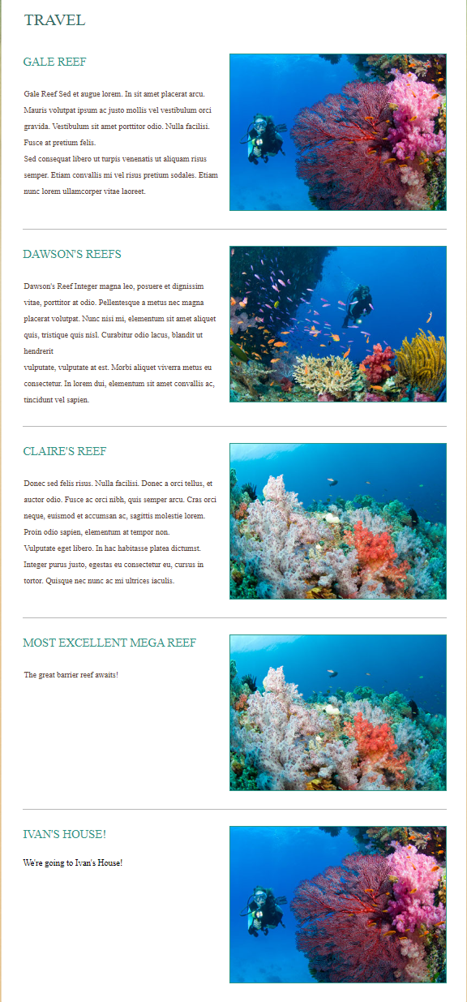
Another Problem:
I found another problem that started with a UI/UX problem. The Angular admin interface, started with a typo in trip-card.html where the Delete button used btnbtn-danger, which is a typo, it should be btn btn-danger, so it rendered as a bland looking black-and-white square. Additionally, the default bootstrap btn-info turquoise comes off a bit ugly and there is even some unprofessional spacing resembling an early 2000s web design rather than anything even remotely modern.
Picture of Angular Interface Before Enhancement:
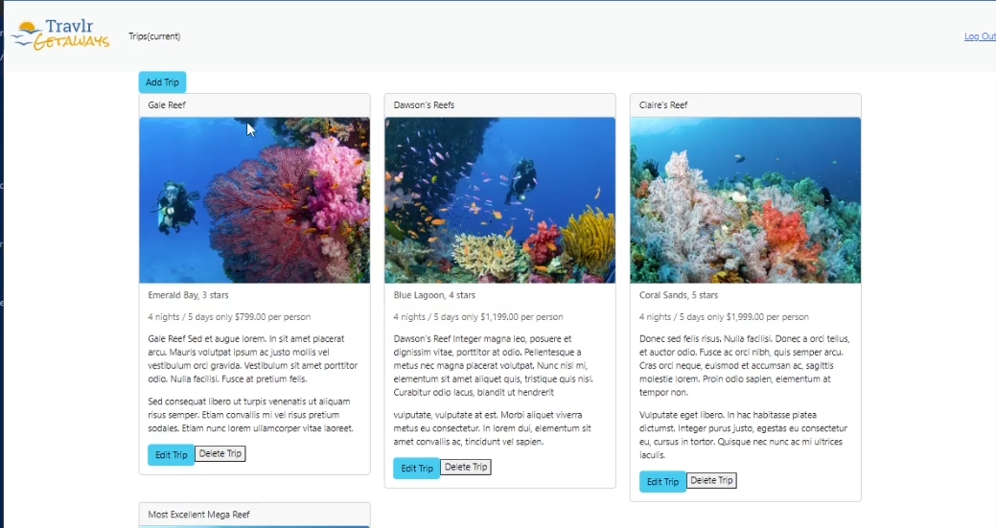
I’m a huge fan of Material Design 3 principles, I’m no expert, but I like the idea of cleaning up an interface. My solution involved:
- Button Styling: Replaced Bootstrap defaults with Material 3 guidance through the CSS. I added a higher radius (8px), subtle shadows, and letter-spacing for a polished look.
- Color hierarchy: Primary actions (Edit/Add Trip) use solid blue buttons, while destructive actions (Delete Trip) use outlined red buttons which mimic other professional designs from other websites.
- Layout consistency: I implemented flexbox across trip-listing.css and trip-card.css to ensure equal card heights and bottom-aligned buttons, eliminating awkward spacing caused by varying description lengths

Picture of Angular Interface After the Enhancement:
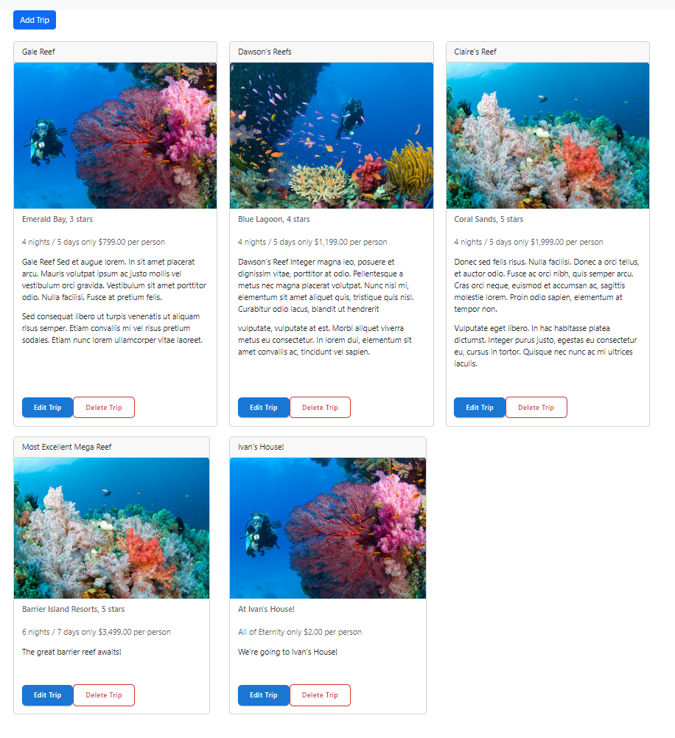
3. Did I meet course outcomes?
Outcome 2: Professional-Quality Visual Communication: I’ve demonstrated this through the delivery of proper visual communications. The layout issues compromised the application’s professional appearance, which would negatively impact user perception and organizational credibility. by ensuring consistent visual presentation in both the button layout and database content, I’ve created a coherent, technical sound interface that adapts appropriately to dynamic content. The before/after screenshots in this narrative demonstrate my ability to document technical improvements in a visually clear manner for audiences.
Outcome 4: Well-Founded Techniques, Skills & Tools: I employed things like CSS principles (block formatting contexts, cascade, specificity) to diagnose root causes. Researched Material Design 3 standards. Implemented scalable solutions that works regardless of database size, ensuring the application delivers values as content grows, followed debugging best practices: hypothesis formation, systematic testing, and incremental changes, modern CSS layout systems (flexbox for equal height cards), visual hierarchy (clear action differentiation). Adding tangible value by making the interface more usable and professional looking.
Outcome 3: Design and Evaluate Computing Solutions: Was not the primary focus of this section, I focused mostly on presentation layer improvements rather than algorithmic optimizations or security hardening. There were minimal code changes, and the most extensive type of refactoring was the flexbox modernization with testing across the entire template. The overflow method on the other hand provided some coding best practices because it provided a fix to an immediate problem while maintaining compatibility with the existing codebase, and minimizing the risk of introducing new bugs, demonstrating my ability to evaluate solutions using computer science best practices while managing real-world design constraints, but it’s not exactly a core algorithm-based improvement.
4.Reflect on the process of enhancing and modifying the artifact:
What did I learn: What I learned was some basic CSS and HTML tweaking and functionality. In terms of the trip display problem, I learned that Static vs Dynamic template designs often fail when connected to databases, and scalable UI implementations must be considered, whether or not they can be done so from the beginning or retrofitted later for the separate Frontend Developer is another question. On the Button side however, my original implementation involved work that primarily focused on backend perspectives, all the CRUD operations functioned correctly, but the interface had some problems that looked amateurish, even including a single typo (btnbtn-danger) and used default colors from Bootstrap.
I learned how CSS cascades through component hierarchies in Angular. Making the card buttons align properly required understanding of systems like flexbox properties needing to flow through multiple HTML levels: the Bootstrap column (col-md-4), the Angular component wrapper (app-trip-card), the card container (.card), and finally the card body (.card-body). Missing any link in the chain broke the layout. This taught me to think about DOM structure and style inheritance similar to how the trip display problem provided a spacing issue that required understanding of paragraph padding rules defined by the site’s specific rules. Learning this process also allows me to find out that my initial assumption that spacing issues were image-specific was incorrect. By testing hypotheses and tracing through the cascade, I discovered the true problem was content-driven padding accumulation rather.
I also learned about Material Design 3 during my android development course. The principles provide a foundational framework for making design decisions rather than just guessing and copying blindly off of other popular designs. (even though M3 is a popular guide regardless). Still though, understanding concepts like elevation (subtle shadows), visual hierarchy (solid vs. outlined buttons for primary vs. destructive actions), and spacing systems made the enhancement process more intentional and defensible.
Challenges I faced: the primary technical challenge was overriding Bootstrap’s opinionated defaults. It wasn’t really a hard challenge but utility classes (btn-info, btn-danger) come with built-in styling that I wanted to override without affecting other parts of the application. I had to learn CSS on the fly, since I didn’t cover it at all during the course, but it was critical to ensure my custom styles took precedence.
The card alignment issue was particularly frustrating because the solution seemed simple conceptually (just make them the same height) but, I ended up just using a flexbox to distribute space across nested containers. The buttons weren’t anchored to the card itself – they floated wherever the description text ended which had varying lengths. Solving this required CSS in both trip-listing.css (for the column layout) and trip-card.css (for the card internals), which wasn’t immediately obvious.
Finally, there was a learning curve in articulating why certain design choices even mattered. It’s one thing to notice whether or not something looks awkward, but another is to understand if it might look awkward or hard to decern to others. Inconsistent button placements create some cognitive friction for users who need to scan multiple cards quickly. This enhancement will fix that I believe, while I don’t have access to other opinions or test runs, it’s considered common practice in most frontend development sectors who balance aesthetics, usability, and technical implementation.

